Diacritical Marks in Microsoft Office
All Iñupiaq diacritical marks (double click to select all and copy): ñ ŋ ġ ḷ ł ł̣
Diacritical Mark | Unicode
Ñ | 00D1
ñ | 00F1
Ŋ | 014A
ŋ | 014B
Ġ | 0120
ġ | 0121
Ḷ | 1E36
ḷ | 1E37
Ł | 0141
ł | 0142
The following diacritical marks are created with 2 unicode characters. 0323 creates the dot under the glyph defined by the first code
Ł̣ | 0141 & 0323
ł̣ | 0142 & 0323

Useful Iñupiaq Words
Iñupiaq
Iñupiat
Iḷisaġvik
Utqiaġvik (Barrow)
Tikiġaq (Pt. Hope)
Here’s how to add words to Microsoft Office!
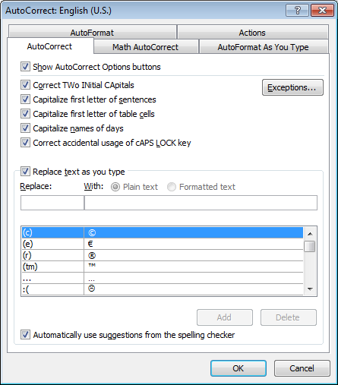
- In Word, select File:Options
- In the Options Window select Proofing
- Click “Auto Correct Options”
- For each line above copy the item to be replaced to “Replace”
- Copy “correct” item to “With”
- Click “OK”

